Name___________________________________________ Date_______________________
Writing the Capitals in Cursive
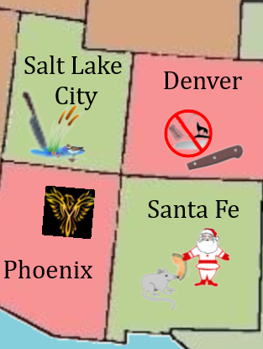 | CO = Denver, Colorado  UT = Salt Lake City, Utah  AZ = Phoenix, Arizona  NM = Santa Fe, New Mexico
