Name___________________________________________ Date_______________________
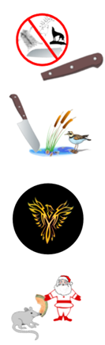
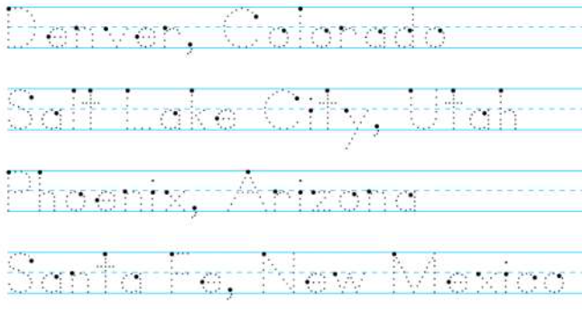
Learning to Print the Capitals
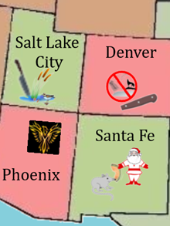 | Denver, Colorado  Salt Lake City, Utah  Phoenix, Arizona  Santa Fe, New Mexico

