Name___________________________________________ Date_______________________
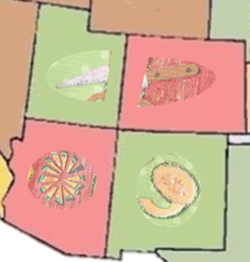 | CO = Colorado  UT = Utah  AZ = Arizona  NM = New Mexico
Learning to Print the 50 States

