Name__________________________________________ Date_______________________
Learning to Print the Capitals

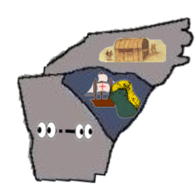 | NC = Raleigh, North Carolina  SC = Columbia, South Carolina  GA = Atlanta, Georgia
