Name___________________________________________ Date_______________________
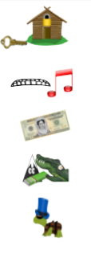
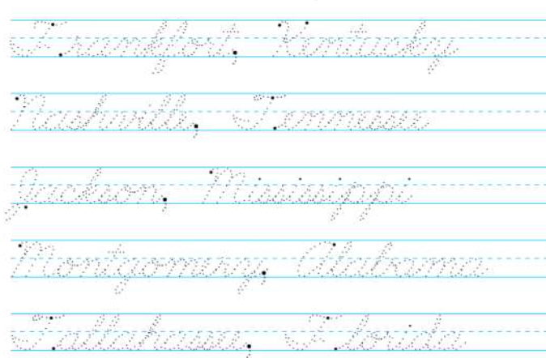
Writing the Capitals in Cursive
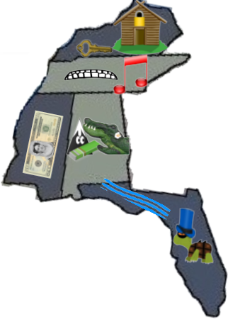 | KY= Frankfort, Kentucky  TN = Nashville, Tennessee  MS = Jackson, Mississippi  AL = Montgomery, Alabama  FL = Tallahassee, Florida

