Name___________________________________________ Date_______________________
Learning to Print the Capitals
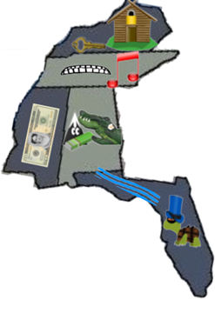 | KY= Frankfort, Kentucky  TN = Nashville, Tennessee  MS = Jackson, Mississippi  AL = Montgomery, Alabama  FL = Tallahassee, Florida
