Name___________________________________________ Date_______________________
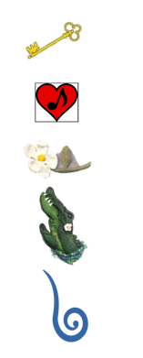
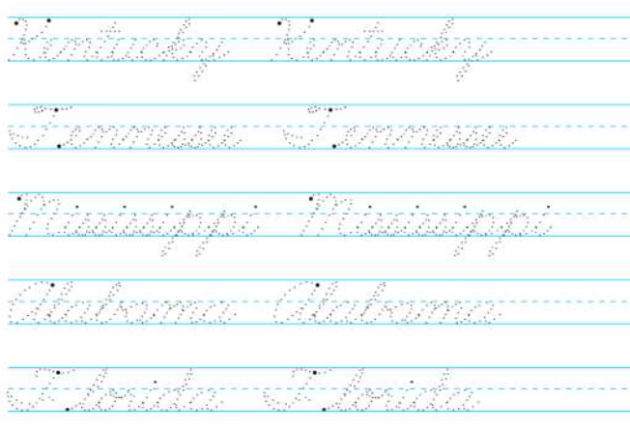
Writing the 50 States in Cursive
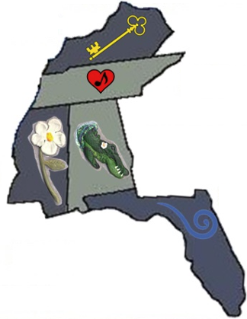 | KY = Kentucky  TN = Tennessee  MS = Mississippi  AL = Alabama  FL = Florida

