Name___________________________________________ Date_______________________
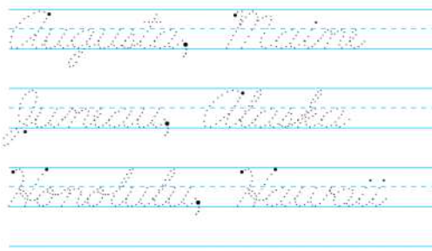
Writing the Capitals in Cursive
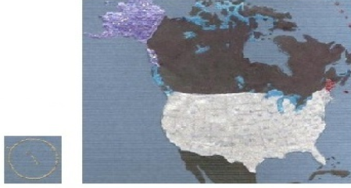  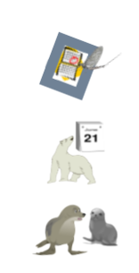 | ME = Augusta, Maine  AK = Juneau, Alaska  HI = Honolulu, Hawaii

