Name___________________________________________ Date_______________________

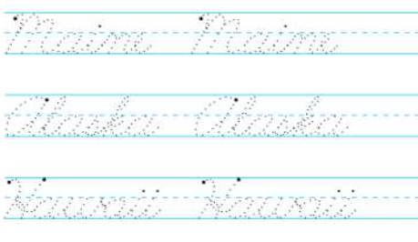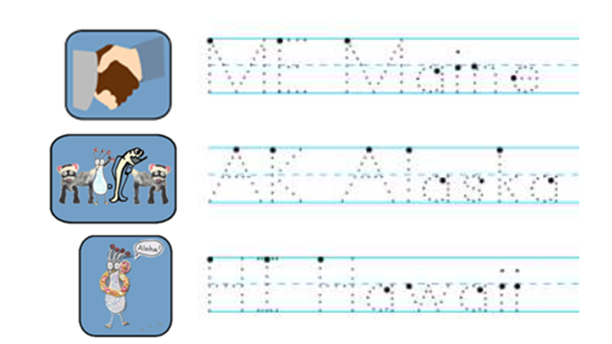 Writing the 50 States in Cursive

|  |  |  |
| --- | --- | --- |
|  | ME = Maine  AK = Alaska  HI = Hawaii |  |

