Name___________________________________________ Date_______________________
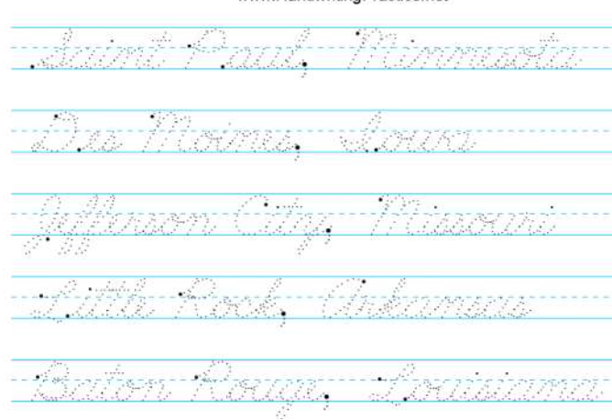
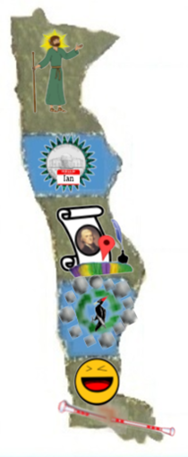
Writing the Capitals in Cursive
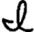
MN = St. Paul, Minnesota
IA = Des Moines, owa
MO = Jefferson City, Missouri
AR = Little Rock, Arkansas
LA = Baton Rouge, Louisiana

