Name___________________________________________ Date_______________________
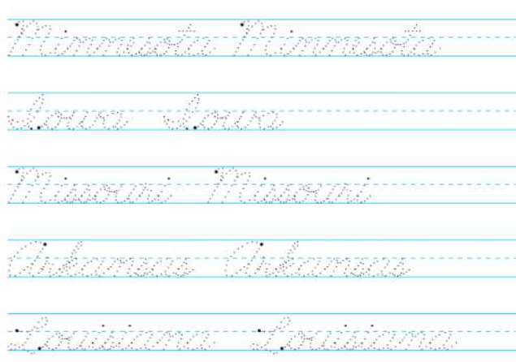
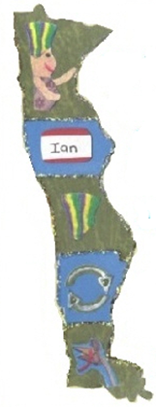
Writing the 50 States in Cursive
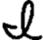
MN = Minnesota
IA = owa
MO = Missouri
AR = Arkansas
LA = Louisiana

