Name___________________________________________ Date_______________________
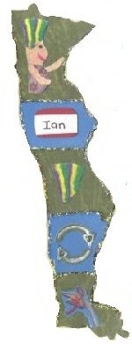
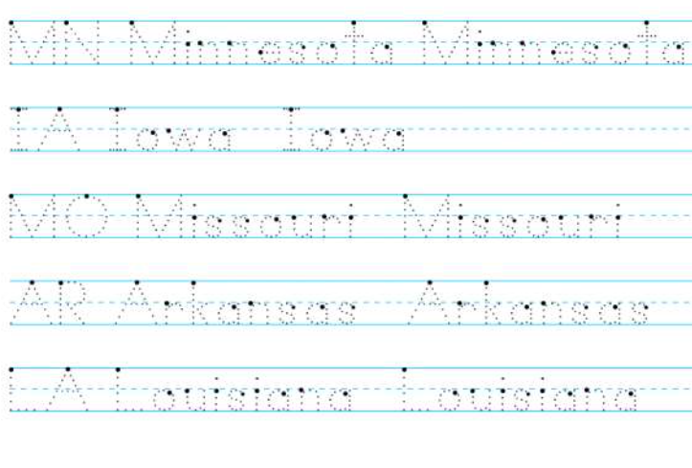
Learning to Print the 50 States
MN = Minnesota
IA = Iowa
MO = Missouri
AR = Arkansas
LA = Louisiana

