Name___________________________________________ Date_______________________

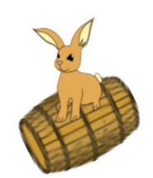 Writing the Capitals in Cursive

|  |  |  |  |
| --- | --- | --- | --- |
|  | **NY** = Albany, New York  **CT** = Hartford, Connecticut  **RI** = Providence, Rhode Island  **MA** = Boston, Massachusetts |  |  |



