Name___________________________________________ Date_______________________

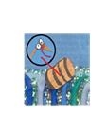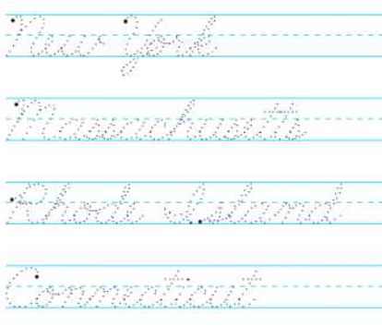 Writing the 50 States in Cursive

|  |  |  |
| --- | --- | --- |
|  | NY = New York  CT = Connecticut RI = Rhode Island  MA = Massachusetts |  |

