Name__________________________________________ Date_______________________
Learning to Print the Capitals
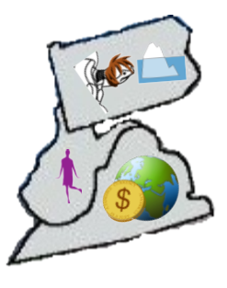 | PA = Harrisburg, Pennsylvania  WV = Charleston, West Virginia  VA = Richmond, Virginia
