Name___________________________________________ Date_______________________
Writing the 50 States in Cursive
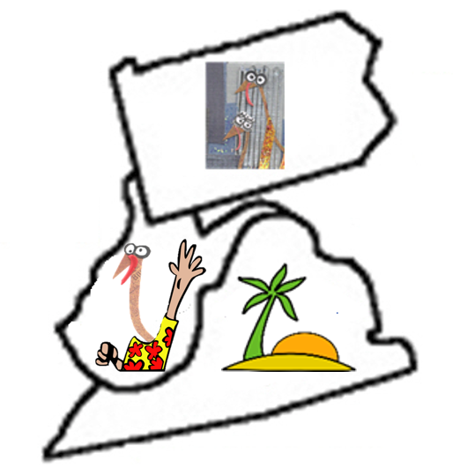 | PA = Pennsylvania  WV = West Virginia  VA = Virginia

