Name___________________________________________ Date_______________________
Writing the 50 States in Cursive
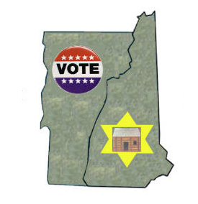 | VT = Vermont  NH = New Hampshire
