Name___________________________________________ Date_______________________
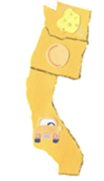 | Olympia, Washington  Salem, Oregon  Sacramento, California
Learning to Print the Capitals

