Name___________________________________________ Date_______________________
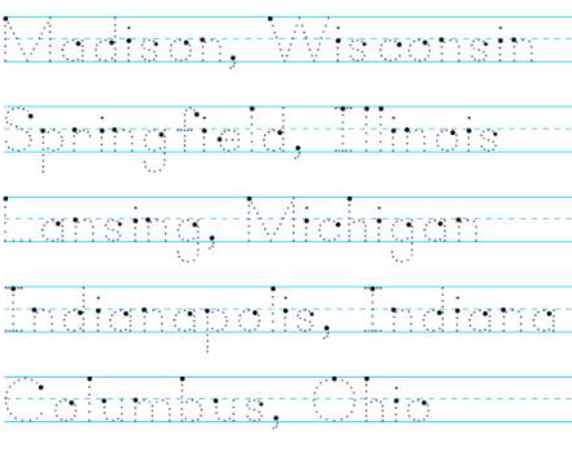
Learning to Print the Capitals
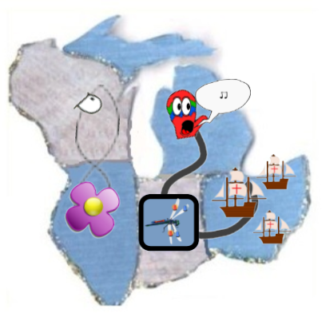 | WI = Madison, Wisconsin  IL = Springfield, Illinois  MI = Lansing, Michigan  OH = Columbus, Ohio  IN = Indianapolis, Indiana

