Name___________________________________________ Date_______________________

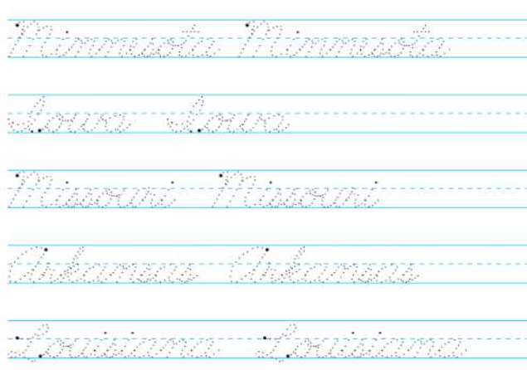 Writing the 50 States in Cursive

|  |  |  |
| --- | --- | --- |
|  | WI = Wisconsin IL = llinois MI = Michigan  IN = Indiana  OH = Ohio |  |



