Name___________________________________________ Date_______________________
Writing the Capitals in Cursive
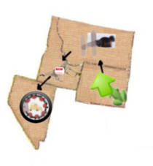 | WY = Cheyenne, Wyoming  MT = Helena, Montana  ID = Boise, Idaho  NV = Carson City, Nevada
