Name___________________________________________ Date_______________________
Learning to Print the Capitals
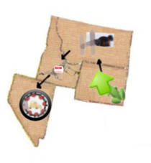 | Cheyenne, Wyoming  Helena, Montana  Boise, Idaho  Carson City, Nevada
